TESTIMONIALS FROM OUR STUDENTS
Name: Pratiksha Mishra  (M-3 Batch 2018-19)   | Organization: National Institute of Pharmaceutical Education and Research, Gandhinagar  Designation: Senior Assistant Administration  “Pursuing IRPM course in HR has been a really enriching experience. The course content is updated and comprehensive to add to one's knowledge Bank. The faculties at BVB Bharuch Kendra made the journey of one year more interesting with their endless reservoir of knowledge.”
Company Name:- UPL LIMITED-12, Dahej  Designation:- HR-TRAINEE  I am thankful to NCSC from where I have completed my PG in COMMERCE & at the same time I have done IRPM from Bhavan’s evening courses and on the basis of that I got an opportunity to join the UPL GROUP AT DAHEJ as a HR Trainee.  While working with the UPL, I realized that I am able to apply my knowledge just because I have learnt the practical approach of studies in IRPM. I am glad that I have been a part of this organization. | Name:- Ronak J Kinariwala  (M-3 Batch 2018-19)  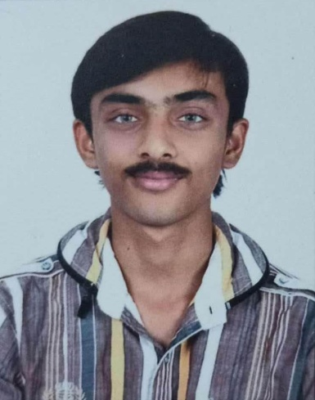
Name: Banti Chadderwala  (M-3 Batch 2019-20)   | Company - Covestro (India) Private Limited, Ankleshwar.  Designation: Manager HR and Admin  Working with one of the best multinational companies from Germany which is a leading polymers player with over 16000 employees across the world. I personally feel that the company believes in its values, vision and culture. It inspires the employees to push boundaries and set a standard for all the people working in this industry. I am very lucky to be part of the Covestro journey.”  IRPM course helps me a lot to improve my knowledge in terms of Labour Law Compliance, in depth knowledge of Industrial Relations & Industrial disputes, Human Relations and their behavior.
Company – M/S Nagindas Hiralal Bhayani, Panoli  Designation: HR & Admin Executive.  College life is a very important part of every individual's life. The college management is structured such as the student representatives as well as the college members. I feel such a good management and staff work and always helpful and innovative teaching to the student is the good part of this college. So due to that when I was completed my PG course (IRPM), I can get good opportunity in M/S Nagindas Hiralal Bhayani, Panoli as a HR & Admin Executive. | Name: Shah Janki A.  (M-3 Batch 2017-18)  
Name: Ravi Mehta  (M-6 Batch 2019-20)  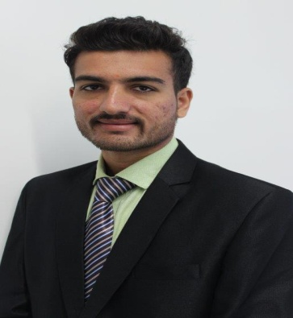 | Company – Abbott Healthcare Pvt. Ltd, Jhagadia  Designation: Officer  "I thoroughly enjoyed my Materials Management and now have very valuable experience under my belt. I know this will help when looking for jobs and needing references. I was dreading it in the beginning, but now I am so happy it was required."  I am heartily thankful to faculty member and whole team of BVB Bharuch !!
Company Name - Glenmark Life Sciences, Ankleshwar  Designation - Officer – HR  I am working in the field of Human Resources since last 4 years. IRPM program of Bhavan has given me opportunity to develop a new angle of view towards the human resources area. Courses of bhavan's has designed in such a fantastic way, it not only gives you knowledge of your particular area but subject like "Cultural heritage" gives you a chance to take a walk in the street of India history and get to know the true colors of our culture, ancient India and thoughts of our Ancestral who setup the base of our country. A project at the end of the course also gives you a practical exposure along with theoretical knowledge. | Name - Rajat Gandhi  (M-3 Batch 2019-20)  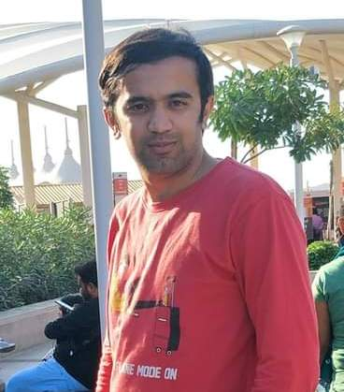
Name - Koushik Majee  (M-6 Batch 2018-19)  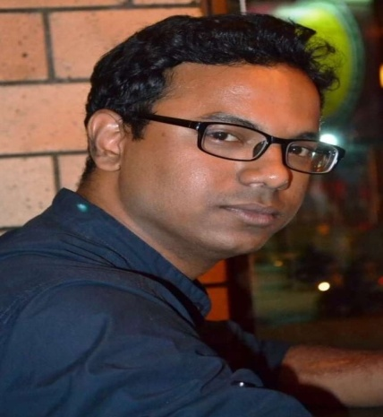 | Company Name - SPX Flow Technology INDIA Pvt. Ltd, Ahmedabad  Designation - Deputy Manager – Materials and Production Planning  The Materials Management course offered by this college is simply great. The faculties are very educated and mostly they are from Industries, sharing practical examples which helped me to understand the applications of the theories better. This course has regular evening classes which encourages the students to be more interactive. Even I have approached the faculties during holidays to clear my doubts and they were very much happy to help. Moreover, the environment of the institution is very beautiful, and the staff members are very much supportive and ready to help anytime.  Undoubtedly, this course helped me to become more knowledgeable materials manager. Thank You.
Company Name - Eskay Iodine Private Limited, Jhagadia  Designation - Store Officer  In the 1 year course of material management in Bharatiya Vidya Bhavan’s Rajendra Prasad Institute at Bharuch, I learnt many new things and many skills of supply chain, purchase, stock maintenance etc. it gave me more confidence and eligibility for make future in purchase department. Heartily thanks to the all teachers who gave us good guidance and support. | Name - Sandipkumar Dodia  (M-6 Batch 2017-18)  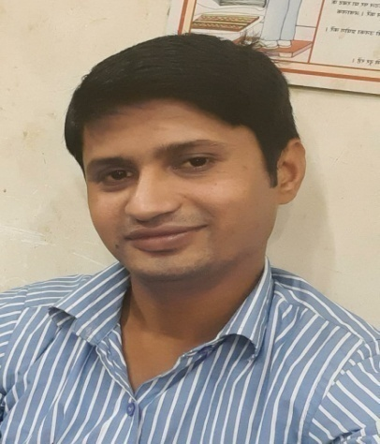
Name - Dhara Dangarwala  (M-3 Batch 2018-19)  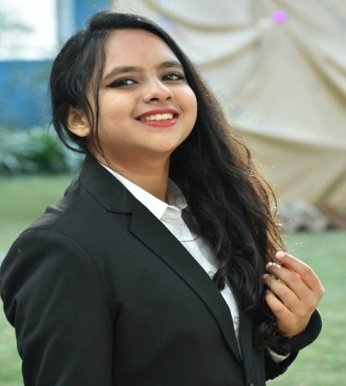 | Company Name - Pioneer Hygeine Products, Dahej  Designation - Hr Trainee  IRPM has helped to grow in both ways personally and professionally too. The knowledge I gained from this course has helped me to understand the work environment and make the job place comfortable for me.
Company Name - Sagar Construction, Ankleshwar  Designation - HR & Account  "Thank you for putting the extra effort during busy time from work. I understand that studying late isn't easy to all, but team of BVB is truly appreciable. So far I never thought it will boost my level of working style & level of thinking. BVB enhances my quality work, value and other which required in work place. Opportunities are on my way which I require, so at last word thanks to BVB team. " | Name - Prakruti Anilkumar Nair  (M-3 Batch 2017-18)  

