FACULTIES
Name | Mr. Chahat Thakkar | 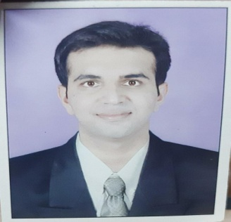
Course | M-6 (Materials Management)
Subject | An Overview of Materials Management
Company | GNFC Ltd. Bharuch
Qualification | MBA, B.TECH
Experience | BVB- 3 Year
Experience | Professional - 11 Year

Name | Mr. Ketankumar Makwana | 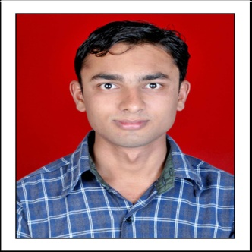
Course | M-6 (Materials Management)
Subject | Purchasing Management, Inventory Management
Company | GNFC Ltd. Bharuch
Qualification | BE, P.G.D.M.M
Experience | BVB- 6 Year
Experience | Professional - 12

Name | Mr. Vinay Mistry | 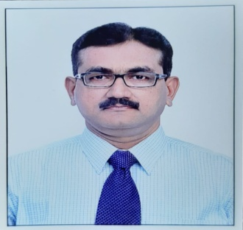
Course | M-6 (Materials Management)
Subject | Store Management - Part-I
Company | GACL Dahej, Bharuch
Qualification | B.com, GDMM
Experience | BVB- 10 Year
Experience | Professional - 25

Name | Mr. T.S. Jhala | 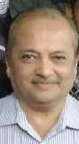
Course | M-6 (Materials Management)
Subject | Store Management - Part-II
Company | GNFC Ltd. Bharuch
Qualification | M.Sc, PGDMM,
Experience | BVB- 28 Year
Experience | Professional – 32 year

Name | Dr. Subhash C Yadav | 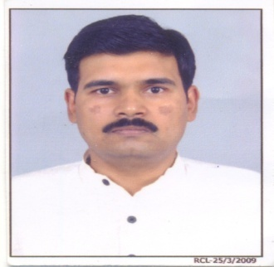
Course | M-3 (IRPM), M-6 (Materials Management)
Subject | Cultural Heritage of India
Company | Associate Professor at Narmada College of Management
Qualification | BE, MBA Marketing, PhD Management
Experience | BVB- 16 Year
Experience | Company- 5 Year, MBA-17 year

Name | Mr. Pankaj B. Shah | 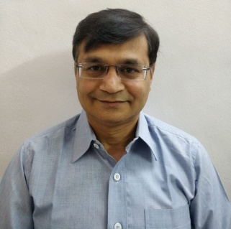
Course | M-3 (IRPM)
Subject | Organisational Behaviour
Company | GNFC Ltd. Bharuch
Qualification | MBA Finance
Experience | BVB- 10 Year
Experience | Professional - 29 Year

Name | Ms. Nisha B. Bagad | 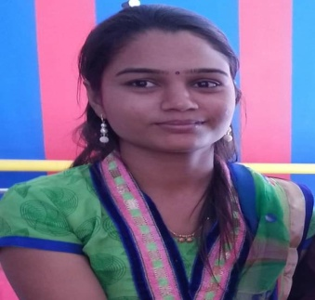
Course | M-3 (IRPM)
Subject | Personnel Management
Company | Proprietor at Alliance Placement Services, Bharuch
Qualification | MLW (Master of Labour Welfare)
Experience | BVB- 6 Year
Experience | Diploma College Palsana- 2 Year

Name | Ms. Pinkal Bhatt | 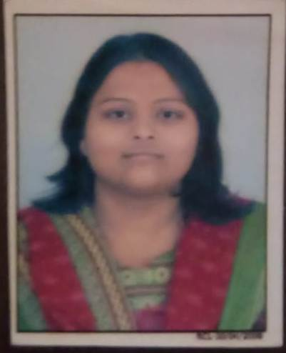
Course | M-3 (IRPM)
Subject | Human Resources Development
Company | Proprietor at Kasturi Corporate Services, Ankleshwar
Qualification | B Com, MBA HR
Experience | BVB- 5 Year
Experience | MBA- 3.5 Year

Name | Mr. Jatin Patel | 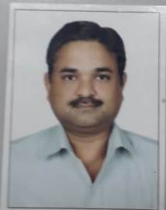
Course | M-3 (IRPM)
Subject | Industrial Relation
Company | GCPL Dahej, Bharuch
Qualification | B. Com, MSW, LLB
Experience | BVB-2 Year
Experience | Professional – 22 year

Name | Ms. Rakhi Thakkar | 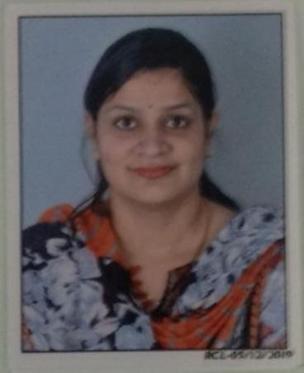
Course | M-3 (IRPM)
Subject | Labour Legislation (Social Security & Social Welfare)
Company | Visiting Faculty Narmada College
Qualification | B.Com, MBA HR+Finance, PGDCA
Experience | BVB- 9 Year
Experience | NCM -4 Year, BBA- 4 Year

